Anusha Shah
Chair, Thames Estuary Partnership
Director, Resilient Cities, Arcadis

Anusha Shah is Chair of TEP and represents the charity at the London Climate Change Partnership. She was previously the Founder & CEO of Plan for Earth, consultancy offering advisory services on Water, Climate Change Adaptation & Resilience, Sustainability and Inclusive Design.
A chartered engineer and a Fellow of the Institution of Civil Engineers (ICE), Anusha has specialisation in Water & Environmental Engineering with nearly 20 years’ experience in designing, managing and leading projects and programmes both in the UK and internationally.
Anusha has been selected as a Visiting Professor for King’s College London on Climate Adaptation & Resilience, Sustainability and Inclusive
Design. She is also Co-Chair of ICE London & South-East Diversity Task Force and an External Examiner in the Civil Engineering and Built
Environment department at the Leeds Beckett University.

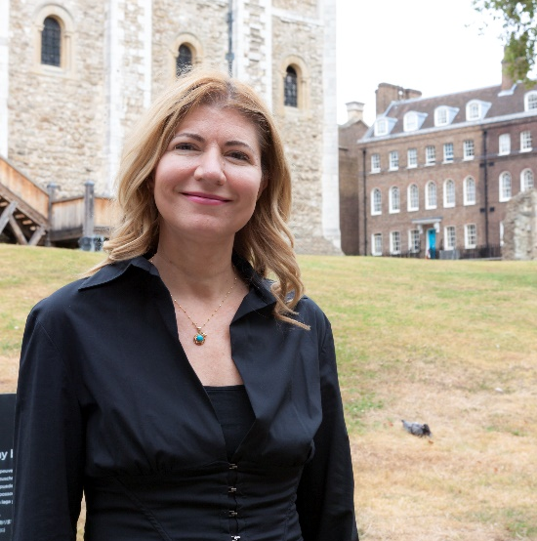 | Heather Hilburn  CEO, Thames Estuary Partnership  Heather is a graduate of the Architectural Association, with many years of experience in the design, planning, delivery and financing of cultural places, as well as the conservation of World Heritage sites of significant heritage and environmental value. Heather previously served as Principal Design Advisor for the Queen Elizabeth Olympic Park, including the transformation of the River Lea. Most recently Heather served as the Strategic Project Director for the Tower of London, authoring the "Tower Future Plan," a masterplan to improve visitor experience. Heather currently serves as a non-executive director for boards focussing on the heritage, data technology and finance sectors.
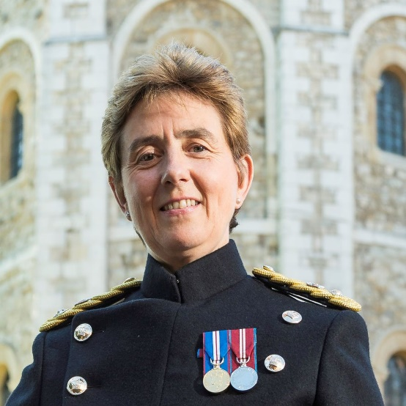 | Debra Whittingham  Deputy Governor, Tower of London  Debra Whittingham joined the Women's Royal Naval Service in 1981, commissioned in 1986. A variety of appointments followed, including Assistant Naval Liaison Officer, London; RN Targeting Intelligence Cell; exchange with the US Navy at the Office of Naval Intelligence; Assistant Staff Officer Operations to Flag Officer Sea Training; Training Officer at RMA Sandhurst and Staff Officer for Higher Command and  Staff Course at Defence Academy, Appointed Commandant of Equality and Diversity Training Centre in 2008. She retired in 2012, to undertake the position of Director of Operations at the Confederation of Service Charities.  Currently, Debra is the Deputy Governor and Head of Operations and Security at HM Tower of London.
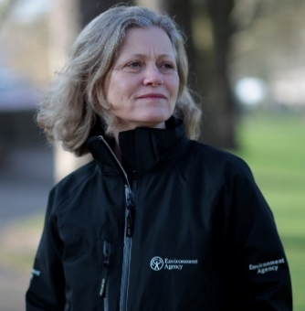 | Emma Howard Boyd  Chair, Environment Agency  Emma Howard Boyd is the Chair of the Environment Agency, an Ex officio board member of the Department for Environment, Food & Rural Affairs, and the UK Commissioner to the Global Commission on Adaptation. Emma serves on a number of boards and advisory committees which include ShareAction, Menhaden PLC, The Prince’s Accounting for Sustainability Project and the Green Finance Institute.  She has worked in financial services for over 25 years, in corporate finance and fund management. As Director of Stewardship at Jupiter Asset Management until July 2014, Emma was integral to the development of their expertise in the corporate governance and sustainability fields.
Fernanda Balata
Senior Programme Manager, Environment and Green Transition
New Economics Foundation

Fernanda Balata is a political economist working at the New Economics Foundation (NEF) since 2013. She currently heads NEF’s Centre for Coastal Economies, a programme of work she developed and has led since 2014.

The Centre works to support the Blue New Deal – a 20-point action plan launched in 2016 and co-developed with hundreds of people on the UK coast to help deliver good jobs, increased wellbeing and economic resilience for coastal communities through a healthier coastal and marine environment. Fernanda is helping to shape NEF’s Green New Deal programme to support the growing movement demanding socially just action on the climate and ecological breakdown.

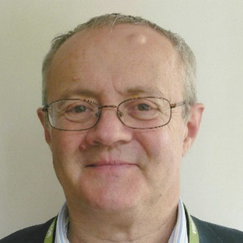 | Dr Martin Hurst  Chair, Southern Regional Flood and Coastal Committee  Dr Martin Hurst became chair of the Southern RFCC in July 2018. He was previously a senior civil servant for 20 years, including as water and floods and then commercial director in Defra and as environment advisor in No 10.  A professional economist, Dr Hurst is also a visiting fellow on major infrastructure at UCL, a member of the expert advisory panel for the UK’s third climate change risk assessment, and a member of the challenge group for the ongoing OFGEM energy networks price review. He has other roles in water and housing and has recently authored a number of articles on sustainability and on project appraisal.
Daze Aghaji
Politics Student and Climate Activist

Daze Aghaji is a 19 year old History and Politics student at Goldsmiths, University of London, who seeks to redefine politics as we know it. Daze first started her journey into social change working at Amnesty International, later followed by Extinction Rebellion. She campaigned as a Climate and Ecological Independent in the European Parliament Elections in May 2019, being the youngest candidate to run. Daze is currently the Coordinator for Regenerative Cultures Working Group at Extinction Rebellion Youth and is an Official Spokesperson for Extinction Rebellion.

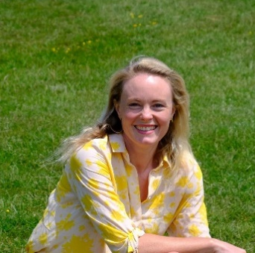 | Hannah Pathak  UK and Europe Director, Forum for the Future  Hannah Pathak has over 18 years' experience leading international partnerships in both the corporate and NGO sectors, working in development, sustainability, and humanitarian response. At Forum For The Future Hannah is the Director for UK / Europe, overseeing a broad portfolio of transformational change projects tackling global challenges such as climate change, sustainable nutrition, and sustainable value chains and livelihoods.
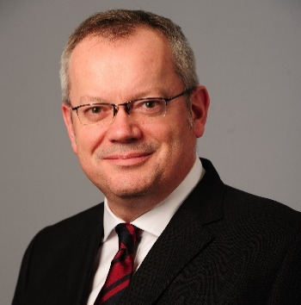 | Peter Hogg  London Cities Director, Arcadis  Peter is Arcadis’ London City Executive, accountable for key activity in the UK’s capital. He also leads for Arcadis on Place-making. A Fellow of the Royal Institution of Chartered Surveyors with 24 years’ industry experience, he has a keen understanding of how to align built and natural assets to the vision, strategy and key priorities of our clients. He has a particular interest in creating successful cities.  Peter has been involved in some of London’s biggest infrastructure programmes of recent years, including the Jubilee Line Extension, St Pancras International Station and Heathrow’s Terminal 5.
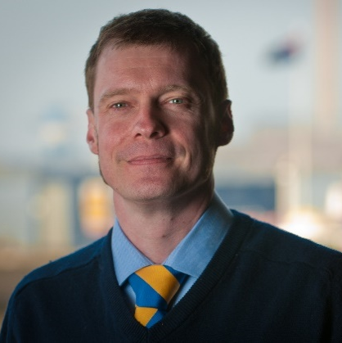 | James Trimmer  Director of Planning and Environment, Port of London Authority  James Trimmer is the Director of Planning and Environment for the Port of London Authority and is responsible for the initiation and implementation of the PLA’s approach to strategic planning, infrastructure, transport and environmental issues throughout the tidal River Thames and its riparian hinterland. He is also responsible for the Authority’s statutory consenting of river works and dredging under of the Port of London Act 1968 and furthermore, is the Project Director for the Authority’s statutory role on the Thames Tideway  Tunnel and Tilbury 2 schemes.
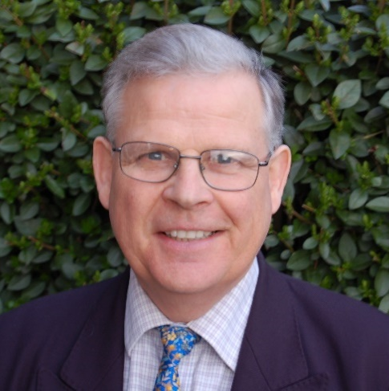 | Andrew Ross  CEO, Global Garden Ltd  Andrew is developing Municipal Green Bonds for England’s 10 major river systems based on the insurance value of assets at risk of flooding.  That known value can be transposed into revaluation of natural capital and sustainable land use which mitigates the risk. Financial institutions can thereby invest in resilient cities and infrastructure at ecosystem scale to meet COP 26 carbon reduction targets.  Global Garden Ltd aims to create Municipal Green Bonds for river systems worldwide.
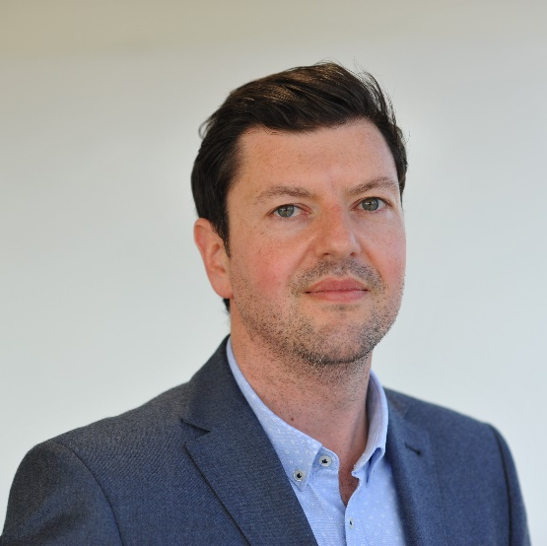 | Thomas Darcy  City Growth Director, Jacobs  Tom Darcy has worked for Jacobs for over 15 years and now leads Jacobs' growth strategy to provide specialist technical services to our City clients, focussing how we can use existing and emerging technology to deliver integrated solutions across disciplines and geographies.
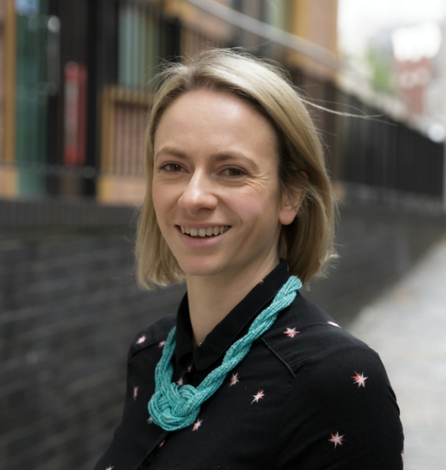 | Katrina Ryan  Director, Mindfully Wired Communications  Katrina Ryan is Director of Mindfully Wired Communications (MWC) - a full-service communications consultancy, working in the marine and environmental sphere. MWC's work is built around community-based, collaborative and creative projects, combining in-house expertise in science, policy, language and arts.  Katrina's career started in environmental policy research and advocacy. Branching out from Westminster to the European Commission, she managed communications for an international participatory research initiative, focused on marine sustainability, across 11 European countries. From there, MWC was formed: now a busy team of eight based in Bristol and working on projects covering the UK, Scandinavia, the Mediterranean, and Antarctica! Within MWC, Katrina continues to work on policy-focused projects, as well as facilitation design, communications strategy, and business development.
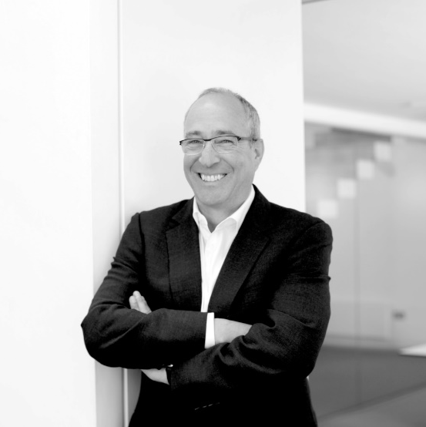 | Alex Lifschutz  Director, Lifschutz Davidson Sandilands  Alex is a Founding Director of the practice, with an approach that is characterised by a sense of curiosity and a delight in people, and in the positive social and psychological impact that architecture can bring. He has had a 25-year relationship with communities and businesses on London’s South Bank, working with the Coin Street Community Builders to regenerate the area through development of co-operative housing, the ground-breaking OXO Tower mixed-use development and the Golden Jubilee footbridges. More recently Alex has been leading the Illuminated River, a public art project lighting up to 15 Thames bridges with the American artist Leo Villareal.
Ben Smith
Director, Energy, Cities and Climate Change Consulting – Arup
Trustee - London National Park City

Ben is an environmental consultant, with 17 years’ experience gained in the UK, Europe, Middle East and Australia, specialising in sustainable development, energy strategy, climate change and urban resilience.

He is a Director in Arup’s planning team and the firm’s global point of contact for partnerships with C40 Cities and 100 Resilient Cities.

Since 2015, Ben has been a Trustee for the National Park City Foundation. He serves as the main liaison between the Foundation and the Greater London Authority.

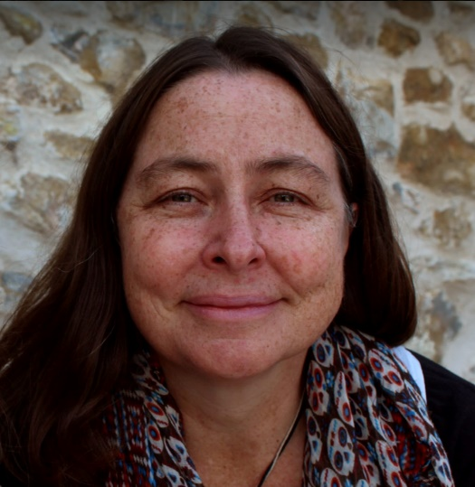 | Sue Ranger  Engagement and Education Manager, Marine Conservation Society  Sue Ranger has worked in marine conservation, community engagement and education for over 25 years. While she grew up in the very middle of South Africa – a thousand kilometers from the ocean – she has always felt a strong connection with the coast and sea. Sue currently leads a small engagement and education team at the Marine Conservation Society, focused on ocean literacy, stakeholder engagement and research. She is a firm believer in the power of working together and plays an active role in both ‘We are Ocean’ and the Marine CoLABoration initiatives alongside progressing innovative, film-based research & engagement projects that take a values-based approach to involving stakeholders in marine resource management issues.
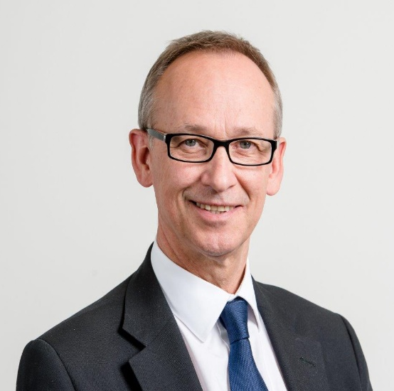 | Phil Stride  Vice Chair, Thames Estuary Partnership  Phil Stride is Strategic Projects Director at Tideway, the largest privately financed infrastructure project in Europe. The company was created to finance and deliver the Thames Tideway Tunnel. He has been working on the project for nearly ten years.  Phil is a civil engineer by trade and has a wealth of experience managing both wastewater and clean water projects in the UK and internationally. He is a Fellow of both the Institution of Civil Engineers and the Royal Institution of Chartered Surveyors.

